Meet the DJ’s

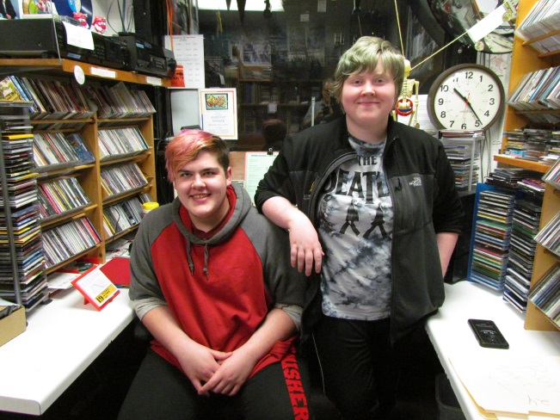

WOAS-FM's day shift is covered by Ontonagon Area School students. Additional students cover the early PM shift that starts right after school is released each day. If there are folks in the area who would like to volunteer and hour or more a week broadcasting their own show on WOAS-FM, please contact Ken Raisanen at 813-0614 Est 113 or email him at ken@oasd.k12.mi.us.
We would like to take the next few weeks to introduce listeners to our current DJs.

Ed MaComber and Ariel Voldarski are the 'old pros' on WOAS-FM this year. Their SKELETON CREW program airs from 10:20 to 11:00 AM every Monday through Friday. They play an eclectic mix of new and old music and, from time to time, bring in guest Sara Davis from Boston, MA via the internet. As the most experienced staffer, Ariel is also the Assistant Manager in charge of a variety of tasks. Both are using their radio time to fulfill some of the 'community service' activities required as part of the Senior Service Project class.

